EX.3.1-CREATE 3D MODEL
FROM
ORTHOGRAPHIC PROJECTION.

AIM
To sketch the given drawing with dimensions using a fusion 360 tool.

REQUIREMENTS

⏺ Autodesk fusion 360
⏺ Windows 10
⏺ Mouse and keyboard
⏺ Computer and Laptop

PROCEDURE
➡ Open Autodesk Fusion 360 and click Create Sketch.
➡ Draw the front view with an outer arc of R16 mm and an inner hole of Ø16 mm.
➡ Draw the main rectangular portion according to the given drawing.
➡ Draw the top view with a horizontal dimension of 52 mm.
➡ Set the thickness of the upper and lower portions to 11 mm each and the middle gap to 18 mm.
➡ Draw the cylindrical portion with a diameter of Ø18 mm.
➡ Set the front-view horizontal dimensions to 36 mm and 32 mm.
➡ Draw the right view with a width of 40 mm and a height of 32 mm.
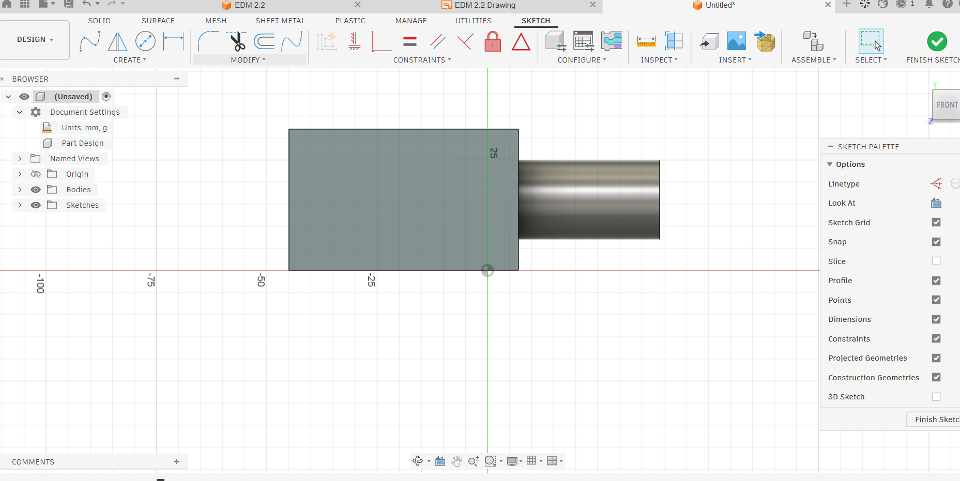
➡ Use the Extrude tool to create the 3D model from the sketch.
➡ Check all dimensions and save the completed model.

OUTPUT

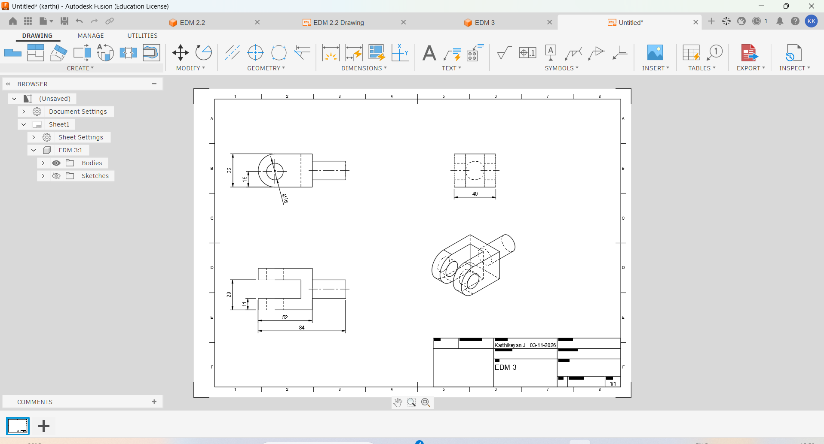

RESULT

Thus, the given sketch is drawn and drafted using a fusion 360 tool

